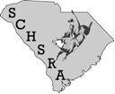
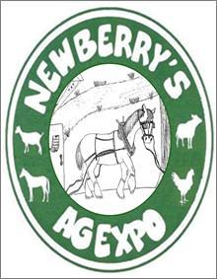
7556 SC Highway 219, Newberry, SC 29108
Featuring SC High School Rodeo
September 9 – 10, 2016
Newberry Agricultural Expo
High School Rodeo encourages our youth to excel in Leadership, Responsibility, Dedication and Commitment. This program is an investment in the lives of some of the finest young people in our state. High School participants from all across South Carolina and North Carolina will compete in 10 events. Livestock action! Rodeo Clown and just Good Family Entertainment!

We seek your sponsorship assistance! It’s a great way to support this community event and promote your products and services!
Here’s how you can help:
Rodeo Sponsor - $2,000
(Top Promotions on ALL Advertisements – company banner on rodeo railing, a rail side sponsor tent (if requested), sponsor announcement during entire rodeo and 8 free passes to both nights along with sponsor reserved parking)

Chute Gate Sponsor - $500 (first 4 sponsors accepted)
(Company banner on chute gate, sponsor announcement during rodeo events and 2 free passes to both nights along with sponsor reserved parking)

Event Sponsors - $300 (per event)

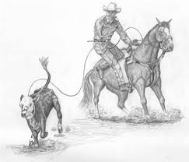
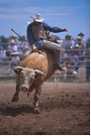
Saddle Bronc Event Bareback Riding Event

Team Roping Event Steer Wrestling Event

Breakaway Roping Event Tie Down Roping Event

Barrel Racing Event Pole Bending Event

Goat Tying Event Bull Riding Event

FOOD Vendor Space - $150 (weekend)

CRAFT Vendor Space (10x10) - $25 (weekend) Individual Sponsor - $____________

NOTE: Ask about non-profit space availability

*******************************************************************************************************************
Sponsor Name: Date:

Contact Name:

Amount: check number Bill Me Cash

Address:
Street City, State, Zip

Email Address: Phone: Fax Number:

Sponsor Notification Deadline: August 15, 2016

Please make checks payable to: www.newberryagexpo.org
Newberry Agricultural Expo
PO Box 1136 Nbyagexpo09@hotmail.com
Newberry, SC 29108
(IRS 501c5 Agricultural Organization)
Rodeo Contact: Allen Sligh (803) 940-0073 or Lisa Sligh (803) 940-0318
Vendor Contact: Alli Graham (803) 940-3411 or Denise Berry (803) 537-0252

Ag Expo proceeds benefiting: Newberry County Ag Expo Scholarships,
Participating Organizations AND Local Agricultural Programs

